D

Date: ________28-05-2017_ Time___6:00________ Full Marks: 50

Name: MANISHA OJHA Branch: ELECTRICAL ENGINEERING

Please read the instructions carefully before attempting.

1. This paper contains 4 sections -Electronics, Structural, Coding and Situational Analysis.
2. You can answer any no. Of questions from any section.
3. The first 5 questions of each section carries 2 marks each and the 6th question i.e. a Long question carries 5 marks.
4. You can edit this document and write your answers just after the corresponding question.
5. You have to send back this edited document containing your answers to [helpdesk.prashikshan@gmail.com](mailto:helpdesk.prashikshan@gmail.com) within 10 minutes of the commencement of your exam.
6. Marks will be deducted if you exceed the time limit or any means of copy –paste answers is found.

For Prashikshan Invigilators only:

|  |  |  |  |
| --- | --- | --- | --- |
| Section | Marks scored | Max Marks | Checked by |
| Electronics |  |  |  |
| Structural |  |  |  |
| Coding |  |  |  |
| Situational Analysis |  |  |  |

TOTAL:

1. STRUCTURAL
2. What is the Degree of Freedom of a Human Arm i.e. From Shoulder to Wrist? Also State Yaw, Pitch and Roll for each joint in the Arm.

**Ans- Human arm has 7 degrees of freedom.**

* **Roll-it is the rotational movement.**
* **Yaw-it is the sideways movement in a horizontal plane.**
* **Pitch- an up and down movement in vertical plane.**

1. How many types of joints are commonly found in Robots?

* **linear joint**
* **orthogonal joint**
* **rotational joint**
* **twisting joint**
* **revolving joint**

1. Which type of Joints are present in the following :-
2. Piston/Pneumatics- **revolving joint**
3. Door Lock- **linear and twisting joint**
4. Pocket Diary
5. What are the Assumptions made in Pin jointed trusses?

* **Stress is constant along the length.**
* **No frictional force in joints.**
* **Mass of the links are neglected.**

1. State Varignon’s Theorem.

**Ans- The theorem states that the moment of a resultant of two concurrent forces about any point is equal to the algebraic sum of the moments of it’s components about the same point.**

1. A block Weighing 500N just starts moving down a rough inclined plane when supported by a force of 200N acting parallel to the plane in upward direction. The same Block is on the verge of moving up the plane when pulled by a force of 300N acting parallel to the plane. Find the inclination of plane and coefficient of Friction.

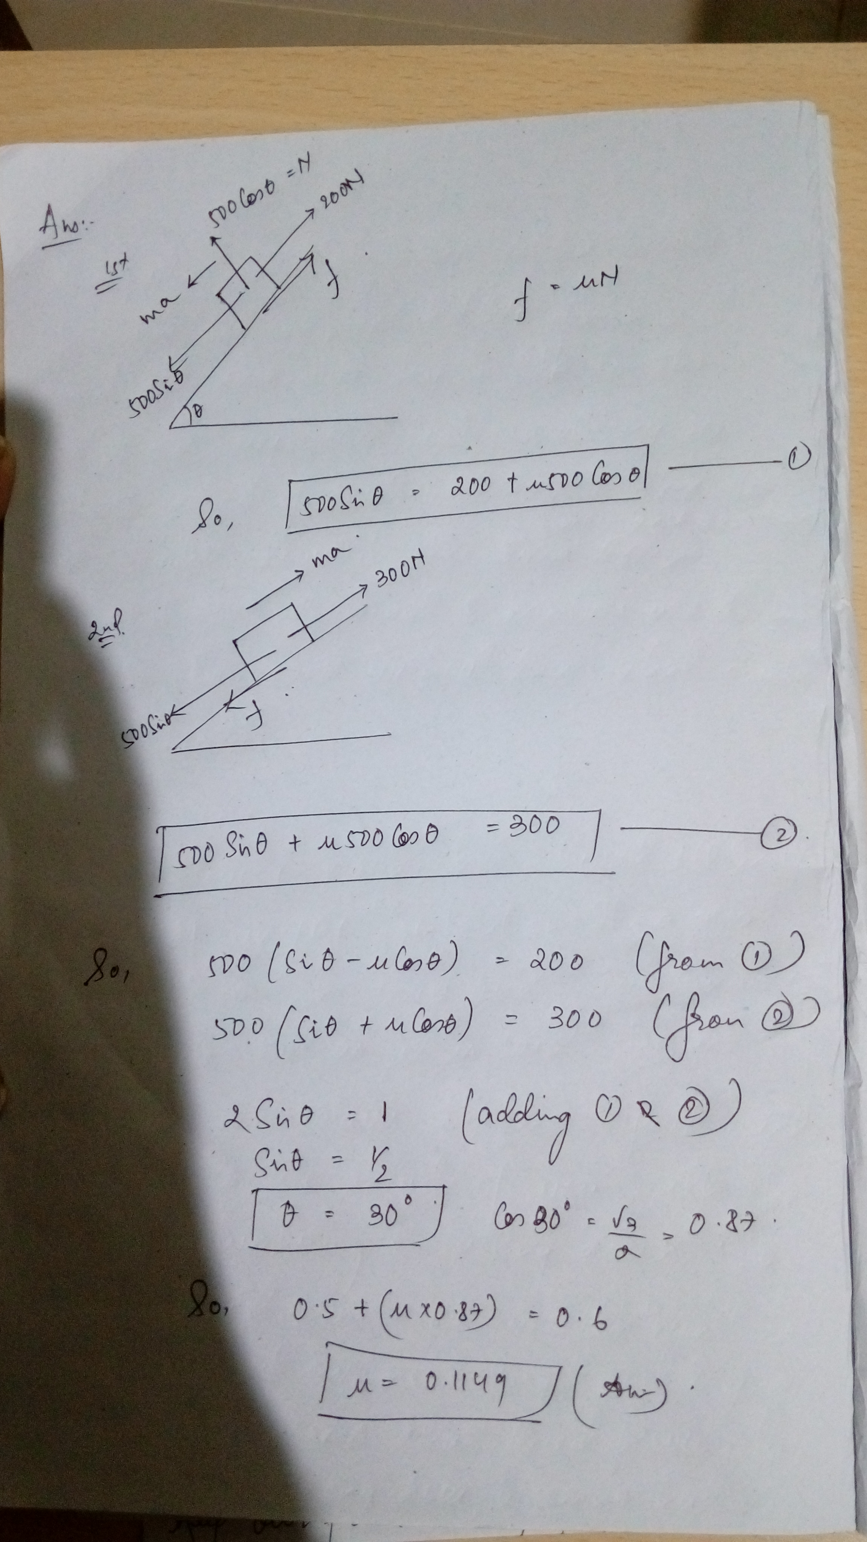

1. ELECTRONICS
2. What are the benefits of LDR? If resistance is low than light is dim or bright and specify the reason.

* **LDR are made up of semiconductor materials which results for their low cost and variety of sizes.**
* **Due to use of semiconductor materials the power and voltage input are very small.**
* **If resistance is low then the light is bright as due to photoconductivity of LDRs incident light intensity increases with decrease in photoresistor.**

1. Which is the good choice among the 2 options mentioned below to get a 12 V output and Why?

* Input Voltage – 24V
* Input Voltage – 48 V

1. What is battery eliminator circuit? Write its function in ESC?

* **BEC are some electrical models which are used in place of battery to reduce the load of carrying these batteries.**
* **Example – in radio systems in aircraft.**
* **ESC are electronic speed control circuits which regulates the speed of the motor. BEC are installed to regulate the voltage instead of using batteries.**

1. Types of seven segment display. And why they are named so.

* **Common anode display – the negative or cathode side of LED are connected to the seven segments of display.**
* **Common cathode display- the anode or positive side of LED are connected to the seven segment of display.**

1. What are the parameters to be considered while designing a buck converter?
2. How does an Ultrasonic sensor Work? Differentiate the work process of IR and Ultrasonic Sensor.

* **Ultrasonic sensor sends a sound wave at specific frequency (frequency range of ultra violet rays) and it bounce back after stricking the object at a particular distance. And after that the distance between the device and object is calculated by noting down the time period to travel that distance.**
* **In ultrasonic sensor sound waves are used but in IR sensor infrared rays are used. Infrared sensor are used to detect IR rays emitted by the LEDs but in ultrasonic sensor sound waves are generated at particular frequency. There is no phenomena like echo in infrared sensor just the receiver detects the IR rays .**

1. CODING
2. What is Switch Debouncing? Write the code for Software based Switch Debouncing.
3. What is Serial Communication? Is it faster than Parallel communication and What all Functions are necessary for a Serial Communication?

* **It is the process of sending data one bit at a time , sequentially, over a communication channel .**
* **Yes it is faster than parallel communication.**

1. Are the Statements similar or Different:

analogWrite(HIGH, Pin) and digitalWrite(HIGH, Pin). State with reason

* **Analogwrite is a pulse width modulated signal where as digitalwrite produces a constant HIGH or LOW.**
* **Digitalwrite sets the pin to an high valuethat remains at that value until and unless digitalwrite called that pin again.**
* **Analogwrite sets the pin to have an oscillating value which has a pulse length based on the duty cycle.**

1. A Bluetooth Module is connected to Arduino UNO. Write a program to read and display the input given to the Bluetooth
2. What is map function in Arduino and it’s uses? Write the syntax for map function.
3. There is a Soil Moisture Sensor which gives Analog output and an Atmospheric Temperature Sensor, and a Motor which takes Analog input and pumps water to the fields. Write a code or Algorithm to ensure that the fields remain in good condition for the Agriculture to sustain.
4. SITUATIONAL ANALYSIS
5. What will be your method of Approach to the Head of our University regarding considering of attendance for 30 members (consisting of 2nd year, 3rd year and 4th years) for a competition, when He/She has already said He/She can permit only 25 students? (2.5 marks)

**Ans- First of all I will talk to the concern faculty guide of robotics club and will take his/her opinion in this regard and then will try to talk to head of our university about considering the attendance of 30 students instead of 25.I will try to direct his thoughts towards the importance and the role that the additional 5 members are playing in the team and without them what are the challenges we will be facing and what could be our position.**

1. Robotics Society, Burla has achieved AIR-21 in ABC competition. Write a short note on how you can still motivate others as well as save the interest and not losing hope of the Alumni and other people on our Club. (2.5 marks)

**Ans- Robotics society Burla, has achieved AIR 21 in ABC competition. It is obviously a great achievement for the club and the university as a whole. But as it is said “the more you climb the stairs the more you will be able to see ahead of you with the risk of stumbling and falling down”. But when we fall a few steps back we should have this much of confidence and hope to stand up and start climbing again so that in the next innings we can grab a better rank . So we as a team members should set up our next target and try to dissolve the problems that faced previously and keep our front strong for upcoming challenges with the motto of climbing up not alone or individually but as a team.**